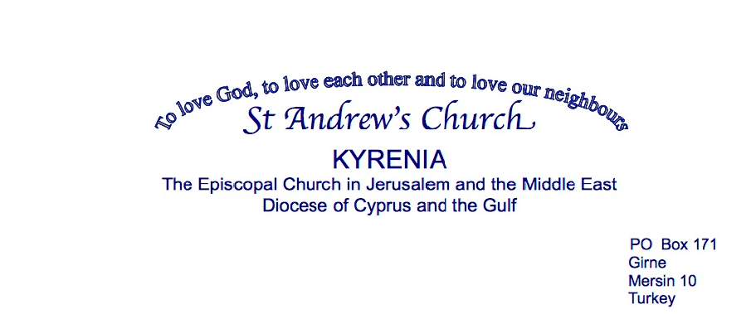

**Parish of St Andrew’s Safeguarding Policy Statement**

The Church Council of St Andrew’s Church, Kyrenia fully recognises and accepts the Safeguarding Policy Statement of the Diocese of Cyprus and the Gulf and commits to complying with the Diocesan safeguarding policy and code of practice.

We shall also comply with legal requirements relating to children and young people and adults experiencing or at risk of harm, abuse or neglect within the jurisdiction of the TRNC.

### We are committed to:

* + Promoting a Safe Church culture within our Parish and in our Parish activities by adhering to safe working practices and acknowledge the principle that no form of exploitation of a vulnerable person can ever be consistent with Christian principles.
  + Ensuring that any organisation renting/using our premises for activities involving children, young people or vulnerable adults is aware of our Safeguarding Policy, and aware of their own responsibilities to have appropriate safeguarding policies and processes in place.
  + Ensuring that all who participate in the life of the church may do so in safety and free from harm.
  + Exercising proper care in the appointment and selection of all those with any responsibilities related to children, young people and vulnerable adults within the Church. References will be required and a role description issued.
  + Ensuring that those appointed are aware of the Diocesan and Parish Safeguarding Policies and are aware of their roles and responsibilities. We will support them by ensuring they receive safeguarding training appropriate to their role and that they are fully aware of and have access to the Code of Practice.
  + Responding promptly to every safeguarding concern or allegation in accordance with the child and adult safeguarding procedures.
  + Ensuring that any complaint made regarding a vulnerable person, who may have been harmed or is in significant danger, will be reported immediately and we will fully cooperate with any investigation into allegations concerning a member of the church community or any other person.
  + Caring pastorally for victims/survivors of abuse and other affected persons.
  + Caring pastorally for those who are the subject of concerns or allegations of abuse and other affected persons.
  + Responding to those who may pose a present risk to others.

### Safeguarding Officer

We will ensure that there is an identified person to be the Parish Safeguarding Officer who will be suitably recruited and trained, who is aware of their role and responsibilities, and who will be the point of contact for any concerns.

We have appointed Linda Balfe as our Parish Safeguarding Officer.

**Guidance**

Copies of Diocesan and parish guidelines and procedures are held by the Parish Priest and Parish Safeguarding Officer.

These are also available on the Parish website and displayed where possible.

Copies have been made available to organisations using church premises, who must either adopt this policy, or have an equivalent policy.

### Review

This policy will be formally reviewed annually by the Church Council and a copy shared with the Diocesan Safeguarding Adviser.

### Date of Adoption

This Policy has been approved by the Diocesan Safeguarding Advisory Panel.

The Church Council agreed and adopted the above Policy at its meeting on 11th October 2023

The date of the next review will be agreed at the first Church Council meeting following the ACM.

### Signed

**Priest** ______________________________________

**Churchwarden** ______________________________________

**Churchwarden** ______________________________________

**Date** ______________________________________