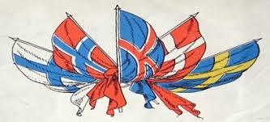

**\*\*Program for Nordic Days 2024\*\***

**October 10th to 20th**

We warmly welcome everyone to the annual Nordic Days in Cyprus. Everyone is cordially invited, regardless of nationality.

**\*\*Thursday, October 10th\*\***

Opening of the Nordic Days 2024 by Willy Lindt

Musical performance by Jussi Lindberg from Finland

Lecture: "The Norwegian-Russian Border Delimitation in 1826 and Its Significance for the Rest of Europe, up to the Current Cyprus Conflict"

By Rune Rafaelsen, former Secretary-General of the Barents Secretariat and former Mayor of Sør-Varanger Municipality, Norway

Serving coffee/tea (light breakfast)

**Time: 10:00 AM**

Location: Kazim Ali Sokak No. 19, Karaoglanoglu

**\*\*Friday, October 11th\*\***

Backyard concert by Sissel Kvambe, Norwegian folk singer

Location: Kazim Ali Sokak No. 19, Karaoglanoglu

**Time: 7:00 PM.** Refreshments/ sausages and a raffle to support the event

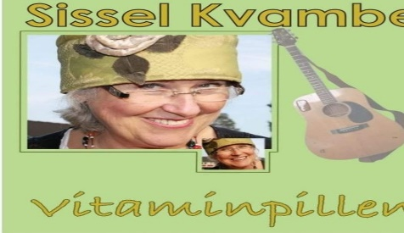

**\*\*Saturday, October 12th\*\***

Nordic gathering at "Tervetuloa Restaurant" in Alsancak

Live music by Finnish artist Jussi Lindberg from Finland

Fixed menu: 1300 TL

Everyone welcome. Overnight stay possible at the restaurant’s hotel, phone: 05338632394

**Time: 7:00 PM**

**\*\*Sunday, October 13th\*\***

Nordic meeting at Birgitta's

Location: Lapta

**Time: 12:00 PM**

**\*\*Monday, October 14th\*\***

Lecture: "The History of the Sami People" (lecture in English)

By Åsmund Røst, history teacher from Norway

Location: Kazim Ali Sokak No. 19, Karaoglanoglu

**Time: 7:00 PM**

Refreshments, sausages, and a raffle to support the event

**\*\*Tuesday, October 15th\*\***

Sing-along in Cyprus with Jussi Lindberg and Sissel Kvambe

Location: Kazim Ali Sokak No. 19, Karaoglanoglu

**Time: 7:00 PM**

Refreshments, sausages, and raffle **to support the event**

**\*\*Wednesday, October 16th\*\***

Concert with Sissel Kvambe from Norway

Location: Sultan Restaurant in Catalkoy

**\*\*Thursday, October 17th\*\***

Nordic Cultural Evening at the Scandinavian Church in Cyprus

Lecture on the history of the Sami people in the Nordic regions by Åsmund Røst, history teacher from Norway

Sing-along/concert by Jussi Lindberg from Finland

Coffee, cakes, and raffle for sale

Location: Ayia Napa

**Time: 6:30 PM**

A bus will be arranged from Girne at 1:30 PM, with a tour to Pila and other places around Ayia Napa, shopping and restaurant visits. Return: 9:00 PM

Price for the bus trip depends on the number of participants.

Registration: palmehagen@gmail.com by October 14th

**\*\*Friday, October 18th\*\***

Concert with Annelis and Terje Holmedahl from the Norwegian Seamen's Church

Serving coffee, waffles, and cakes

Location: Kazim Ali Sokak No. 19, Karaoglanoglu

**Time: 6:30 PM**

**\*\*Saturday, October 19th\*\***

Terrace party in Karsyaka with Jussi Lindberg from Finland

**Time: 7:00 PM**

**All events have free entry.**

**Contact phone: Tommy Rognmo 05338476908**

**Email: palmehagen@gmail.com**